

Submitted By:
Ali Abbas– 2025-CYS-45
Assignment:
Pacman Game
Submitted To:
Sir Shahmeer Nawaz

For the fulfillment of,
Object-Oriented Programming Lab
Department of Computer Engineering
University of Engineering and Technology, Lahore

Graphical Representation

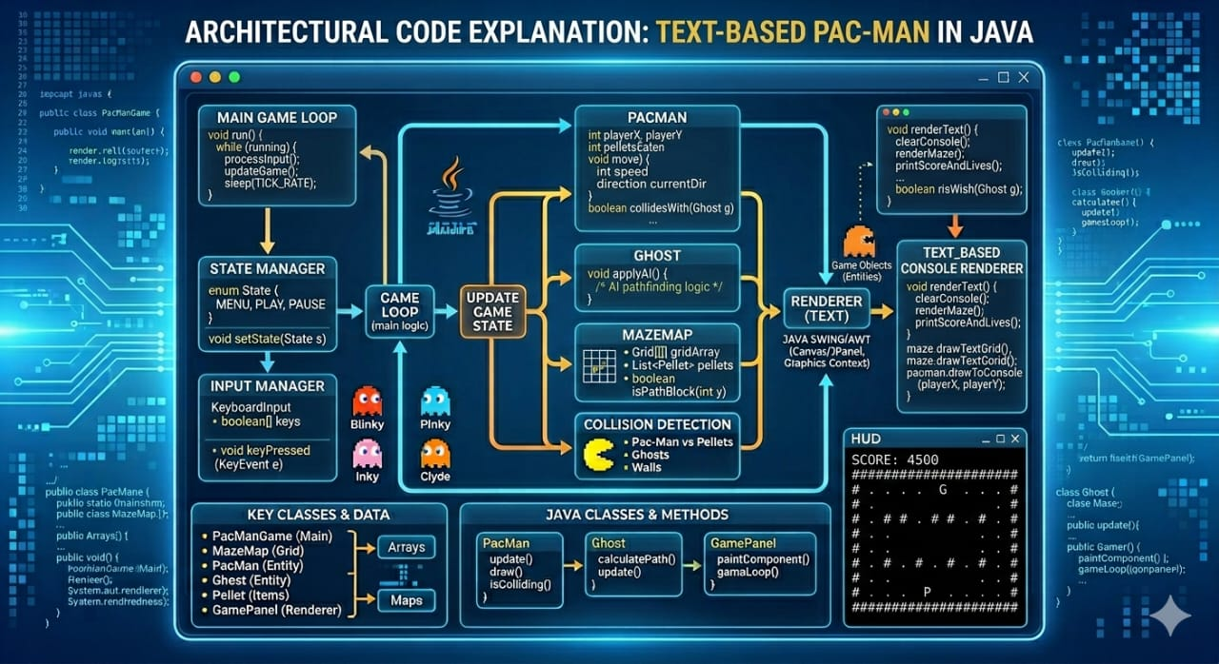

Pacman Project - Architecture & Implementation

1. Introduction
This project focuses on developing a simplified Pacman-style game utilizing Java and core Object-Oriented Programming (OOP) principles. The primary objective is to maintain clean, logical code by delegating specific responsibilities to distinct classes. The game operates on a grid-based system with the following symbols:
- @: Represents Pacman
- G: Represents the Ghost
- #: Represents Walls
- .: Represents Food dots
The player controls Pacman via keyboard input (w/a/s/d), aiming to consume all food while avoiding the ghost.
2. Core Class Architecture
PacmanGame (The Main Controller)
Serving as the "brains" of the application, this class manages the overall flow:
- Main Method: Contains the entry point for the program.
- Object Initialization: Instantiates the GameBoard, Pacman, and Ghost objects.
- Game Loop: Executes the logic for taking user input and updating entity positions.
GameBoard (The Environment)
This class acts as the world manager, focusing strictly on the layout rather than movement control:
- Map Storage: Maintains a 2D array (grid) representing the play area.
- Collision Rules: Identifies the location of walls and food.
- Rendering: Responsible for printing the board to the console.
Pacman (The Player)
Represents the user-controlled entity:
- State Management: Tracks current position (row, col) and the player's score.
- Movement Logic: Interacts with the GameBoard to navigate around walls.
- Resource Collection: Consumes food tiles to increase the score.
Ghost (The Enemy)
Represents the automated adversary:
- Movement: Moves randomly across the board each turn.
- Navigation: Restricted from passing through wall tiles.
3. Game Logic & Rules
- Initialization: The board, player, and ghost are placed in their starting positions.
- Turn-Based Loop: The game repeatedly prints the board, accepts input, and updates the positions of both Pacman and the Ghost.
- Win/Loss Conditions:
- Loss: Triggered if Pacman and the Ghost occupy the same tile.
- Win: Triggered once all food dots have been removed from the board.
- Scoring: Each consumed food dot adds +1 to the score, which is tracked in the Pacman class and displayed after every move.
4. Project Limitations & Future Scope
Current Constraints
- Basic AI: The ghost moves randomly and does not actively hunt the player.
- Turn-Based: The game is not real-time; it only progresses when the player moves.
- Interface: Limited to a text-based console output with no graphical UI.
- Survival: There is no "lives" system; a single collision results in an instant Game Over.
Future Improvements
- Implementing Pathfinding AI (e.g., A* algorithm) for smarter ghosts.
- Adding a Graphical User Interface (GUI) for a better visual experience.
- Introducing Multiple Ghosts and a Lives System to increase difficulty.
Conclusion:
By separating concerns into distinct entities, the project establishes a clean, scalable foundation. This modular approach proves that even complex interactions can be simplified through structured class hierarchies, providing a clear path for future enhancements like GUI integration or smarter pathfinding.

